SOFTWARE RE-ENGINEERING
Refactoring Report
Introduction
This report presents a comprehensive overview of the design defects identified during the code review and the corresponding refactoring’s applied to improve the code quality. The aim of this refactoring effort was to enhance code readability, maintainability, and performance while reducing technical debt and minimizing the risk of future bugs.
Summary of Design Defects Observed
File Name | Code Smell / Design Defect | Description
package-info.java | Fully Qualified Annotation | Used fully qualified annotations, resulting in verbose and cluttered code.
package-info.java | Annotation Placement | Misplaced annotations reduced readability and increased potential for misinterpretation.
JsonAdapter.java | Missing Javadoc Inclusion | Lacked proper documentation, making the purpose and usage of the interface unclear.
JsonAdapter.java | Inconsistent Meta-Annotation Order | Meta-annotations were inconsistently ordered, violating code style guidelines.
JsonAdapter.java | Stray/Duplicate Code & Broken Comments | Contained duplicate code and poorly formatted comments, leading to potential misunderstandings.
TypeToken.java | Large Class / Mixed Responsibilities | Had excessive methods with unrelated responsibilities, reducing cohesion.
TypeToken.java | Duplicate, Scattered Validation Logic | Validation logic was spread across multiple methods, violating the DRY (Don't Repeat Yourself) principle.
ReflectionAccessFilterHelper.java | Mixed Responsibilities | Methods handled unrelated tasks, complicating maintenance.
Primitives.java | Duplication of Mappings | Repeated mapping logic increased maintenance effort and risk of inconsistency.
Primitives.java | Long if/OR Chains | Contained overly verbose and error-prone conditional checks.
Streams.java | Redundant Code Structure | Contained repetitive logic and lacked clear null-safety handling.
UnsafeAllocator.java | Code Duplication in Anonymous Classes | Repeated logic increased the potential for errors.
PreJava9DateFormatProvider.java | Duplication of Pattern Literals | Repeated patterns across multiple methods increased code complexity.
NumberLimits.java | Magic Numbers | Used unexplained numeric constants, reducing code clarity.
NonNullElementWrapperList.java | Tight Coupling | Constructors tightly coupled to specific implementations, reducing flexibility.
LazilyParsedNumber.java | Non-Lazy Conversion Method Naming | Method names implied immediate parsing, leading to potential performance issues.
ConstructorConstructor.java | God Class / Large Class | Combined multiple unrelated responsibilities into a single class.
RuntimeTypeAdapterFactory.java | Large Class, Long Parameter List, Duplicated Code, Poor Encapsulation, Complex Type Handling, Primitive Obsession | Too many responsibilities, long constructors, direct field access, and complex logic.
UtcDateTypeAdapter.java | Long Method, Primitive Obsession, Excessive Comments, Large Class, Magic Numbers, Complex Conditional Logic | Combined multiple responsibilities with heavy use of primitive types and unclear code.
GraphAdapterBuilder.java | God Class, Tight Coupling, Lacks Modularity | Overly large class structure with mixed responsibilities.
SQL Types | Duplicate Code, God Class, Temporal Coupling, Tight Coupling | Repeated logic, scattered state handling, and tight dependency on specific SQL types.
Intercept Annotation | Complex Generics, Inconsistent Documentation | Overly complex generics and lack of clear documentation.
JsonPostDeserializer Interface | Redundant Modifiers, Lack of Encapsulation | Used redundant modifiers and lacked proper encapsulation.
InterceptorFactory Class | Complex Adapter Creation, Tight Coupling | Mixed concerns in factory methods and direct access to internal logic.
InterceptorAdapter Class | Poor Encapsulation, Lack of Modularity | Mixed responsibilities without proper encapsulation.
General State and Token Handling | Large Methods, Magic Numbers, Poor State Management, Complex Conditionals | Overly complex methods, poorly managed states, and excessive use of magic numbers.
ExclusionStrategy.java | Tight coupling to FieldAttributes | Direct dependency on FieldAttributes limits flexibility.
ExclusionStrategy.java | No contextual decision-making | Lacks support for runtime context in decision logic.
ExclusionStrategy.java | Generic interface naming | Interface name does not clarify serialization/deserialization intent.
FieldAttributes.java | Hard dependency on Java reflection | Makes it difficult to use alternative metadata sources.
FieldAttributes.java | No context-aware logic | Does not support conditional behavior based on serialization/deserialization.
FieldNamingPolicy.java | Redundant transformation logic | Repetitive and complex camel case handling logic.
FieldNamingPolicy.java | Poor extensibility | Adding new naming conventions requires modifying existing enum.
FormattingStyle.java | Missing final modifier | Class is immutable but not marked final.
InstanceCreator.java | Missing @FunctionalInterface | Interface is a SAM but lacks annotation.
JsonArray.java | Manual and incorrect serialization | Overrode serialization logic instead of using Gson's built-in methods.
JsonDeserializer.java | Verbose and unclear documentation | Overly complex comments and inconsistent formatting.
JsonIOException.java | Unclear constructor and parameter naming | Used 'msg' instead of 'message', and included redundant comments.
JsonNull.java | Improper Singleton handling | Public constructor allowed multiple instances of JsonNull.

List of Changes / Refactoring’s Applied
File Name | Refactoring Applied | Description
package-info.java | Import & Replace FQN | Replaced fully qualified annotation with imported variant for clarity.
package-info.java | Move Annotation Above Package | Corrected annotation placement for consistency.
JsonAdapter.java | Add @Documented | Added Javadoc annotations to improve code self-documentation.
JsonAdapter.java | Reorder Meta-Annotations | Standardized meta-annotation order for consistency.
JsonAdapter.java | Remove Extraneous Fragments | Removed stray code and fixed broken comments.
TypeToken.java | Extract Class | Separated unrelated validation logic into a dedicated nested class.
TypeToken.java | Consolidate Duplicate Code | Moved scattered validation logic into a centralized validator.
ReflectionAccessFilterHelper.java | Single-Responsibility Methods | Broke down methods to align with single responsibility principle.
Primitives.java | Centralized Mappings | Consolidated mappings into a single, well-defined data structure.
Primitives.java | Simplified Conditional Logic | Replaced complex if/OR chains with clearer logic.
Streams.java | Simplified Logic and Added Null-Safety | Reduced complexity and added null-safety checks.
General State and Token Handling | Extracted Methods, Constants, and Improved State Management | Broke down large methods, replaced magic numbers, improved state handling, and simplified conditionals.
UnsafeAllocator.java | Encapsulated Common Logic | Centralized repeated logic into shared private methods.
PreJava9DateFormatProvider.java | Centralized Patterns | Extracted repeated patterns into a centralized map for consistency.
Intercept Annotation | Simplified Generics, Improved Documentation | Reduced generic complexity and added clear documentation.
JsonPostDeserializer Interface | Removed Redundant Modifiers | Cleaned up interface for better encapsulation.
InterceptorFactory Class | Extracted Adapter Creation Logic | Moved adapter creation logic to separate methods for clarity.
InterceptorAdapter Class | Improved Encapsulation | Made a private static nested class for better encapsulation.
ExclusionStrategy.java | Interface Split and Context Support | Split into Serialization and Deserialization strategies; added context-aware method support.
FieldAttributes.java | Decoupled Reflection and Context Support | Introduced support for alternative metadata and runtime context.
FieldNamingPolicy.java | Refactored and Modularized Naming Logic | Centralized camel case logic into reusable utilities.
FormattingStyle.java | Marked Final and Cleaned Comments | Marked class final and simplified Javadoc.
InstanceCreator.java | Modernized Interface | Added @FunctionalInterface and removed redundant modifiers.
JsonArray.java | Used Gson toJson() | Replaced manual serialization logic with standard Gson serialization.
JsonDeserializer.java | Cleaned and Clarified Documentation | Simplified Javadoc and clarified parameter roles.
JsonIOException.java | Renamed Parameters and Cleaned Comments | Improved constructor parameter naming and removed redundant comments.
JsonNull.java | Singleton Pattern Enforcement | Made constructor private and clarified singleton usage.

CLASS DIAGRAMS
BEFORE REFACTORING:
EXTRAS:
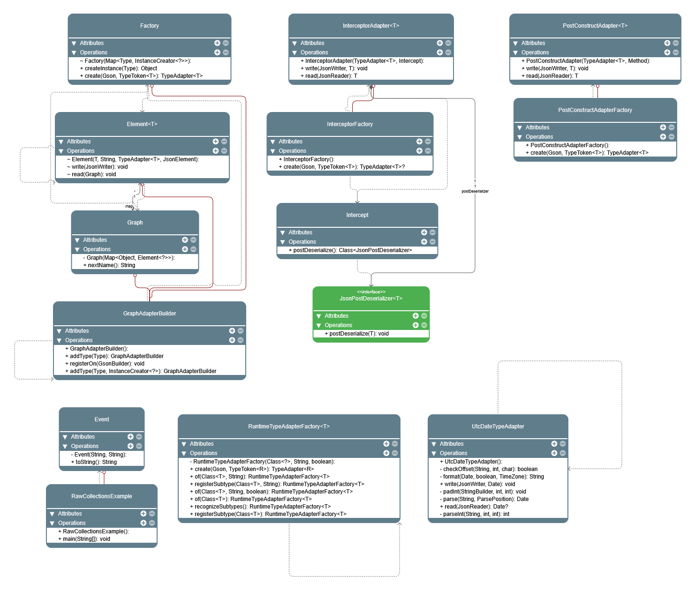

GSON :
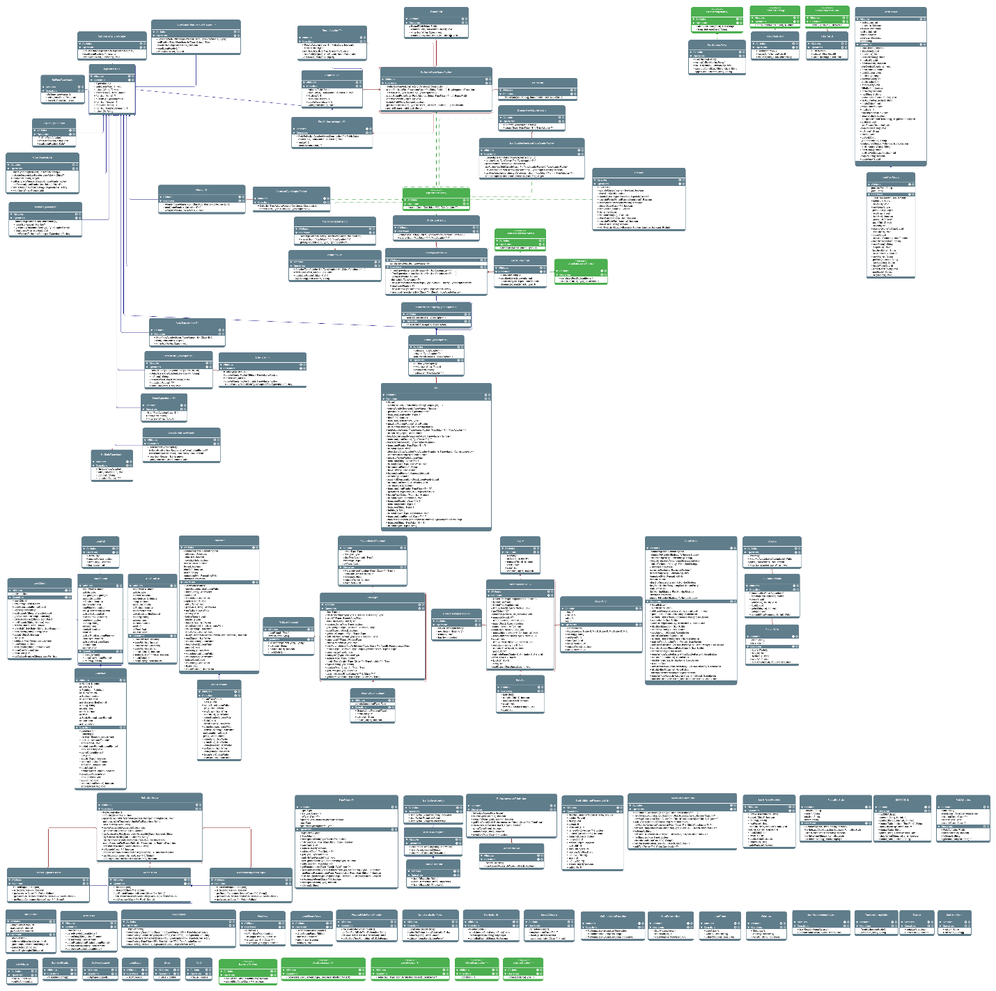

Metreics:

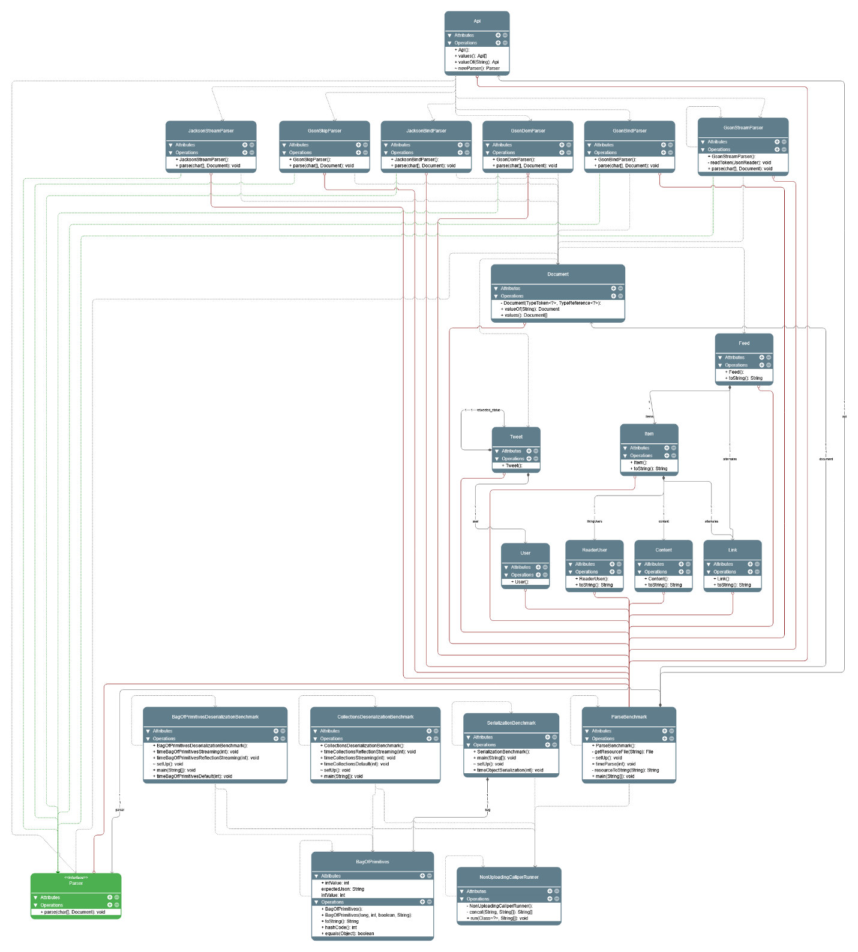

Gson/internal:
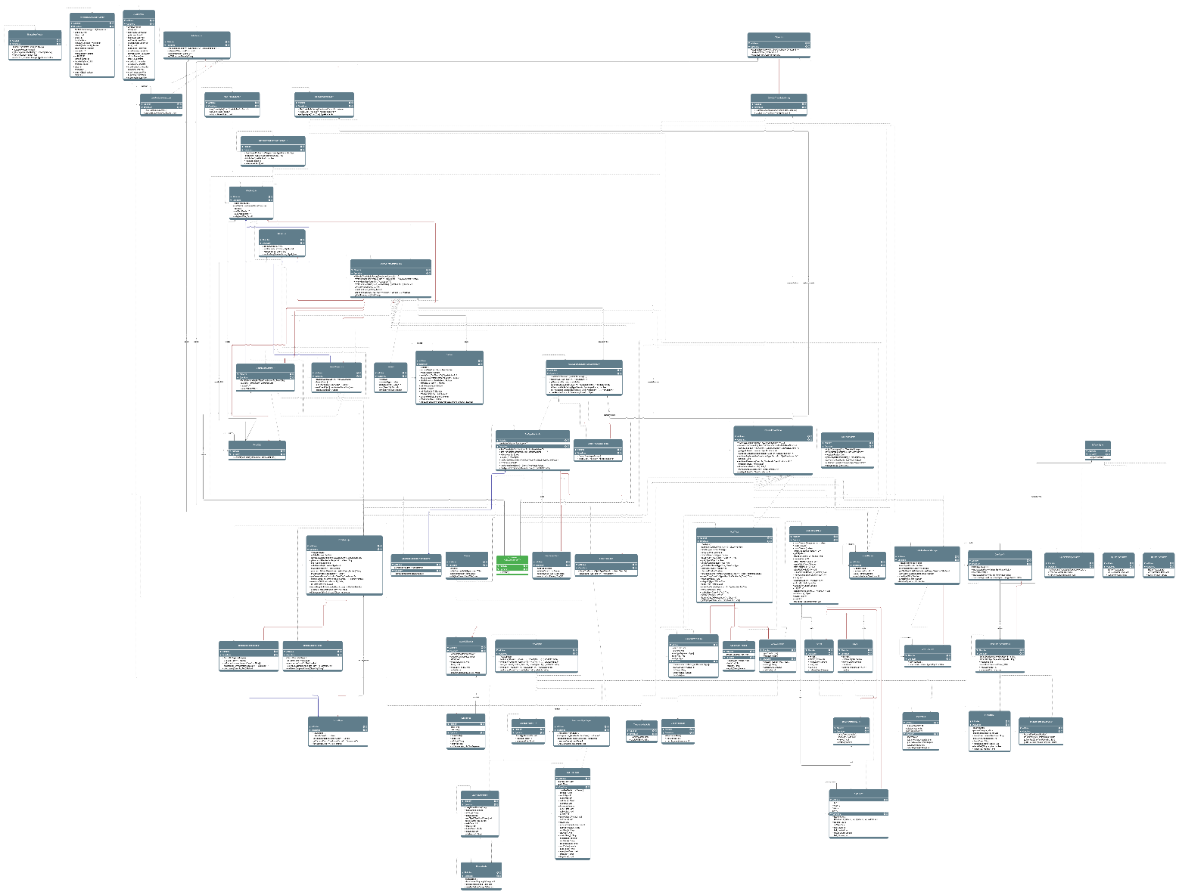

Gson/internal/bind:
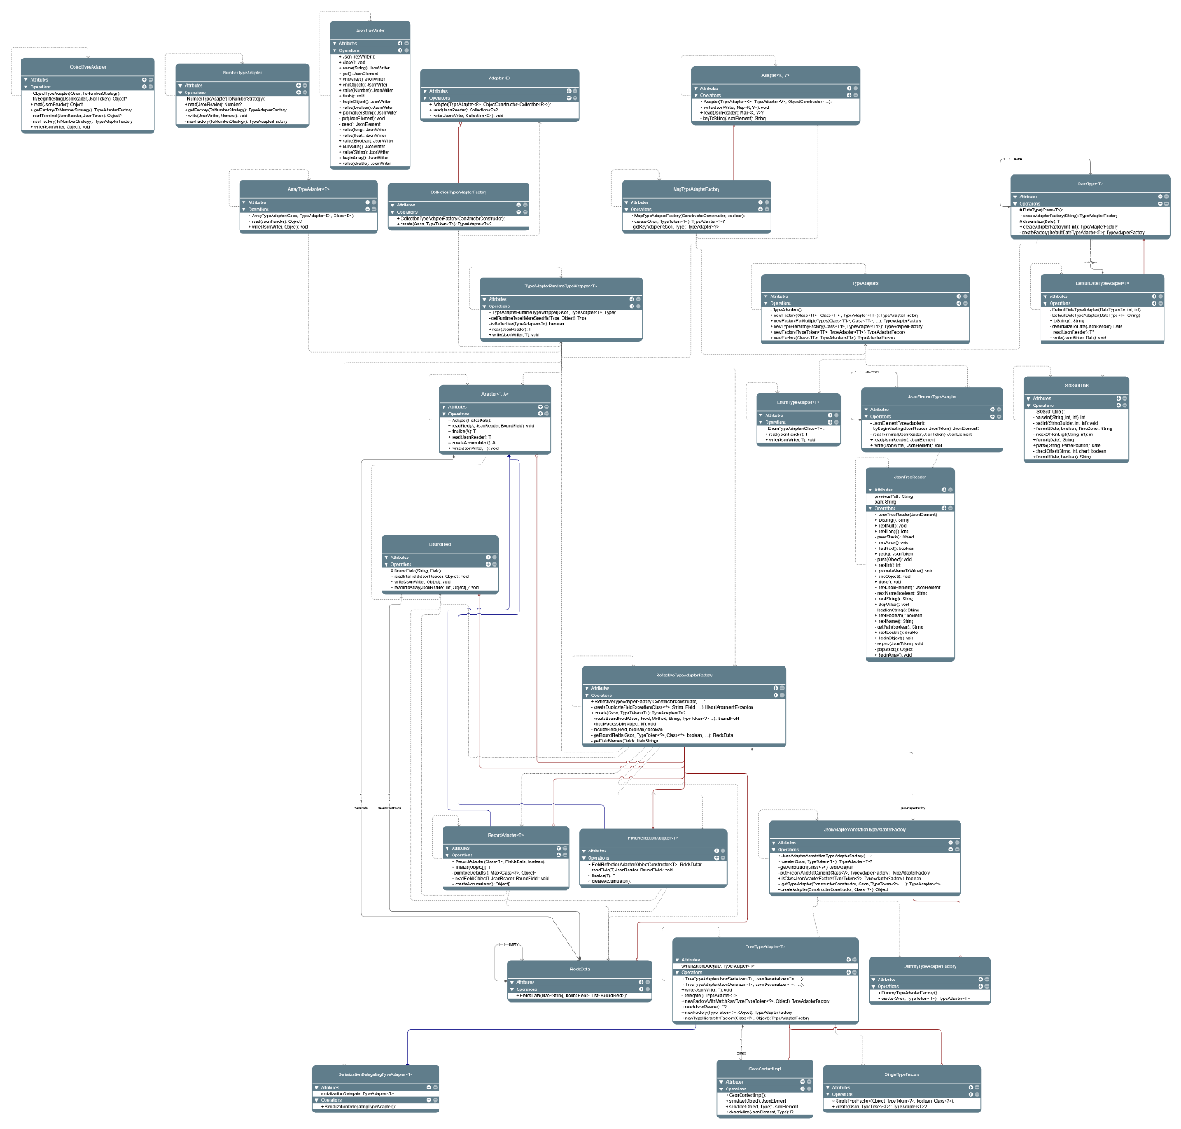

Gson/internal/sql:
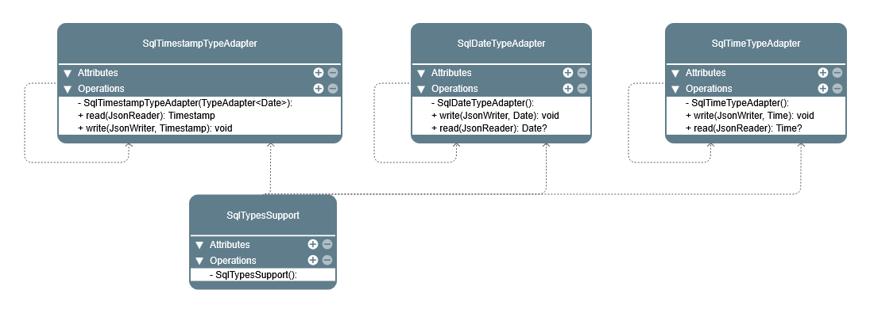
Gson/stream:
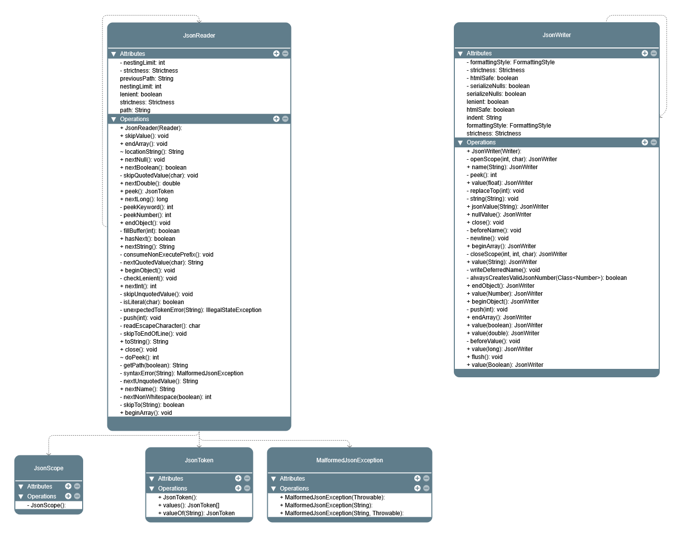

AFTER REFACTORING
Extras: 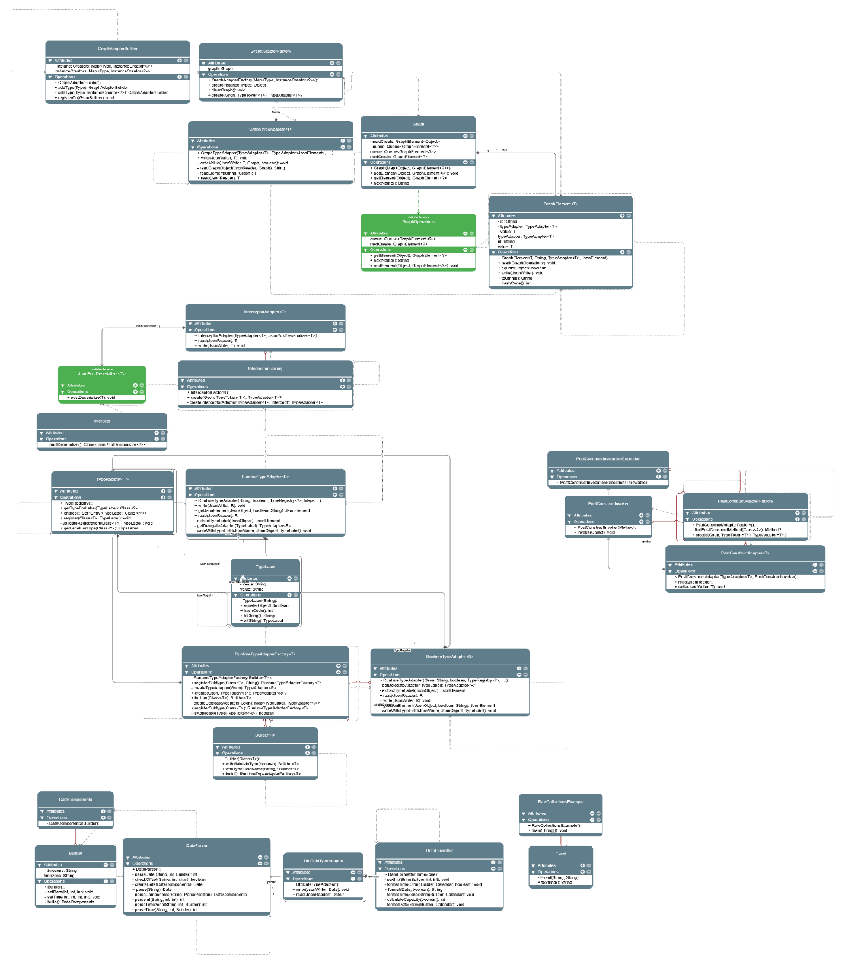

Gson:
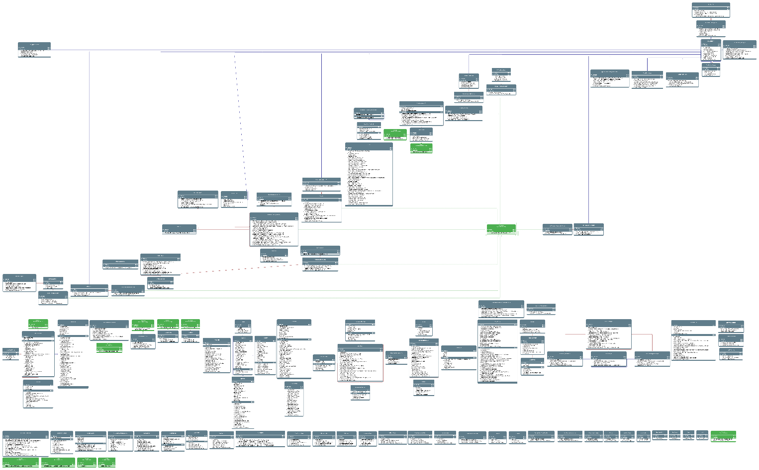

Gson/internal:
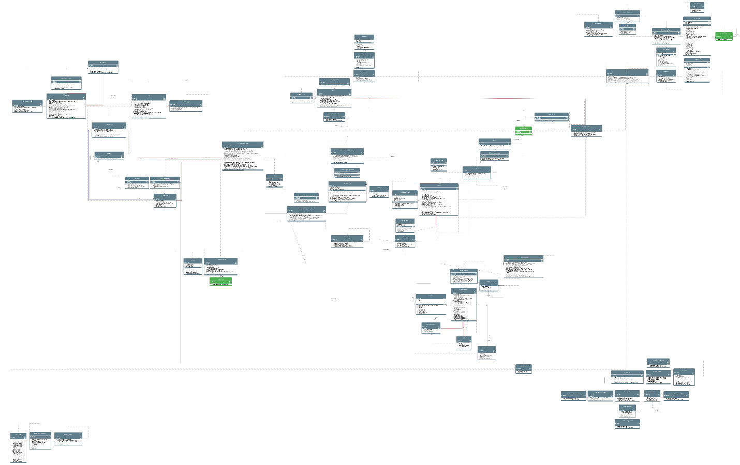

Gson/internal/bind:
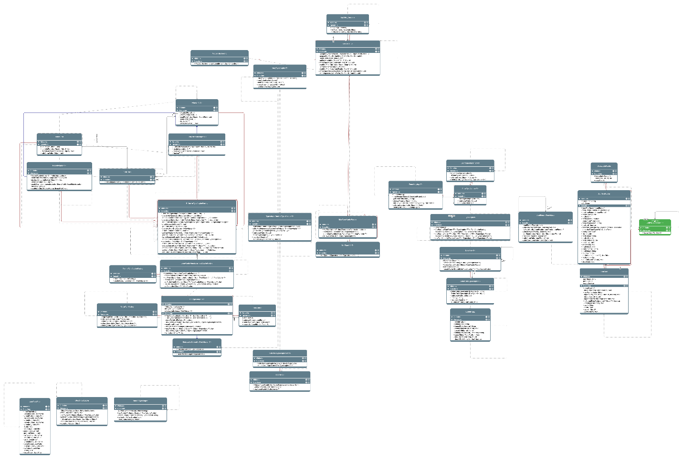
Gson/Internal/sql:
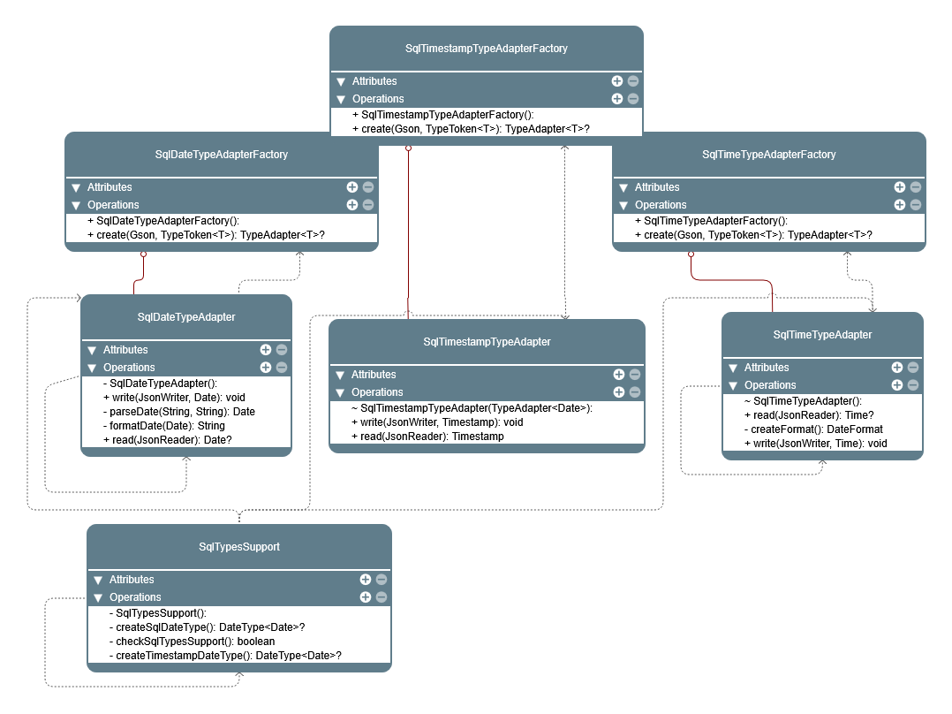

Conclusion
This refactoring effort significantly improved the codebase by eliminating code smells, enhancing readability, and simplifying complex logic. These changes are expected to reduce technical debt and improve maintainability, making the codebase more robust for future extensions and modifications.

TASK DISTRIBUTION:
WORK | MEMBERS
Class Diagrams | Ayesha, Mahrukh
Code smells | Ayesha Haroon, Mahrukh, Aman, Ayesha
Refactoring | Ayesha Haroon, Mahrukh, Aman, Ayesha
Test Cases | Ayesha Haroon, Aman,Mahrukh,Ayesha
Report Compilation | Ayesha, Aman

